**WEB PROGRAMING PRACTICUM REPORT**

**MODULE 7**

**CSS**



**CREATED BY :**

**KURNIAWAN BAGASKARA**

**L200214253**

**INFORMATICS STUDY PROGRAM**

**FACULTY OF COMMUNICATION AND INFORMATION SCIENCE**

**MUHAMMADIYAH SURAKARTA UNIVERSITY**

**Experiment 1**

<html>

<head><title>Border</title>

<style *type*="text/css">

    p*.dotted* {border-style:dotted}

    p*.dashed* { border-style:dashed}

    p*.solid* {border-style: solid }

    p*.double*{ border-style: double }

    p*.groove* {border-style: groove }

    p*.ridge*{ border-style: ridge }

    p*.inset* {border-style: inset }

    p*.outset* { border-style: outset }

</style>

</head>

<body>

    <p *class*="dotted">A dotted border</p>

    <p *class*="dashed">A dashed border</p>

    <p *class*="solid">A solid border</p>

    <p *class*="double">A double border</p>

    <p *class*="groove">A groove border</p>

    <p *class*="ridge">A ridge border</p>

    <p *class*="inset">An inset border</p>

    <p *class*="outset">An outset border</p>

</body>

</html>

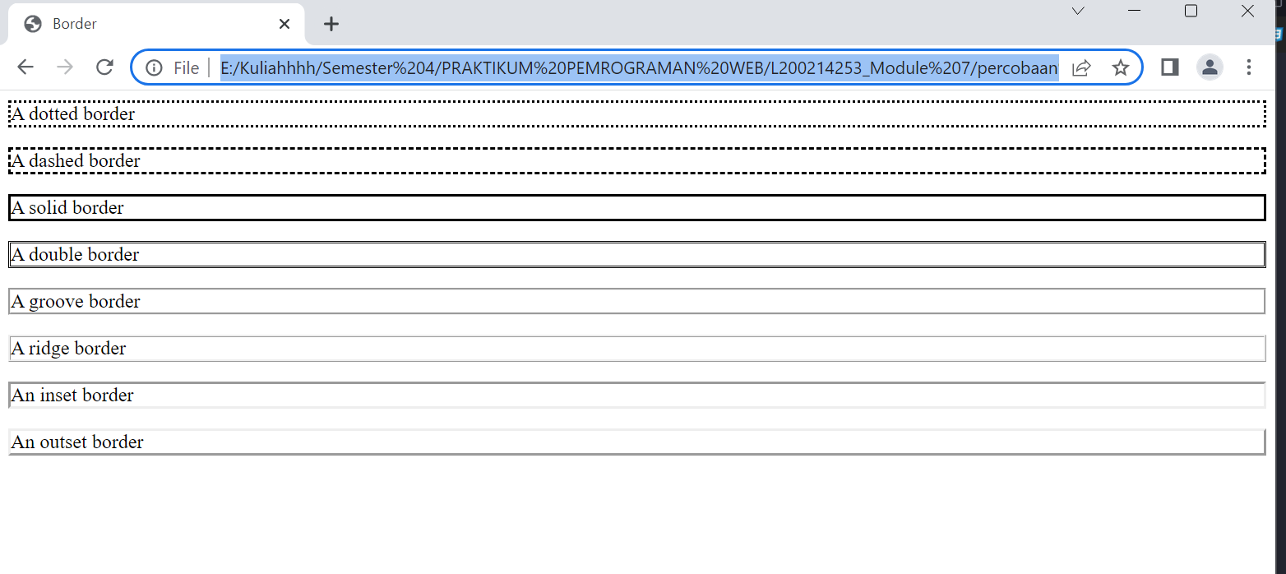

**Experiment 2**

<html>

<head>

<title>Gambar</title>

<style *type*="text/css">

body

{

background-image:url("gambar.jpeg");

background-repeat:no-repeat;

background-position:center center;

background-attachment:fixed;

}

</style>

</head>

<body>

</body>

</html>

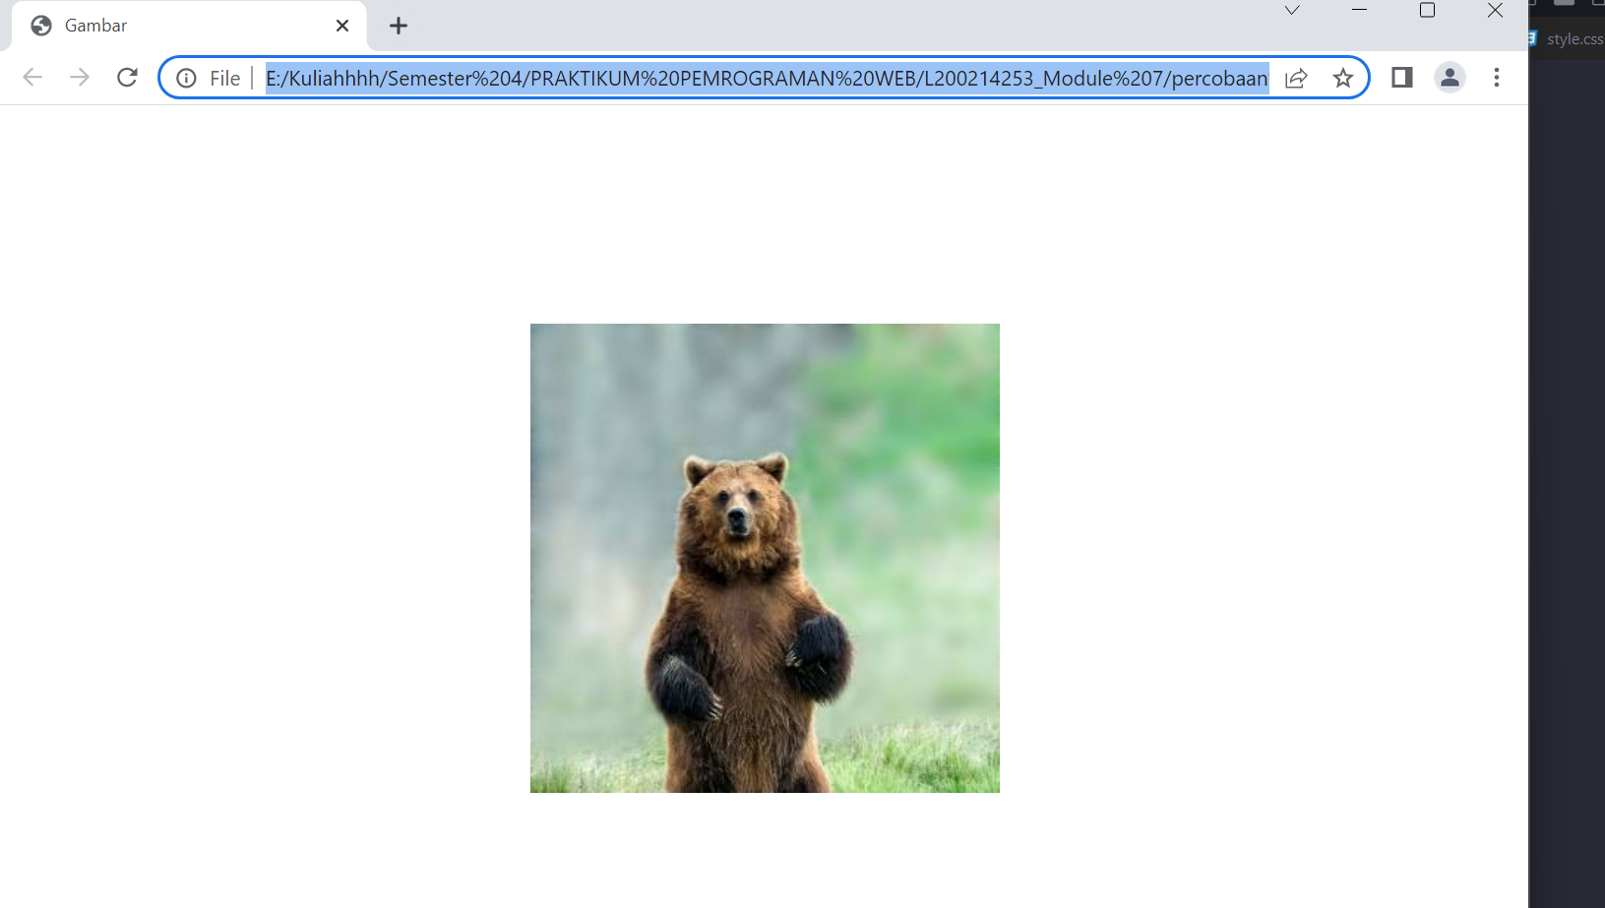

**Experiment 3**

<html>

<head>

<title>Bayangan</title>

<style *type*="text/css">

H1{text-shadow: 5px 5px 5px #FF0000}

*.posisi1* {position:relative; top:15;

left:25; z-index:10; color:#000000; fontfamily:arial; font-size:25pt}

*.posisi2* {position:relative; top:-22;

left:28; z-index:6; color:#00ccff; fontfamily:arial; font-size:25pt}

*.posisi3* {position:relative; top:-59;

left:29; z-index:6; color:#ff00ff; fontfamily:arial; font-size:25pt}:

</style>

</head>

<body>

<div class='posisi1'>Pemrograman

Web dengan CSS</div>

<div class='posisi2'>Pemrograman

Web dengan CSS</div>

<div class='posisi3'>Pemrograman

Web dengan CSS</div>

<h1>Efek Bayangan dengan CSS3</h1>

</body>

</html>

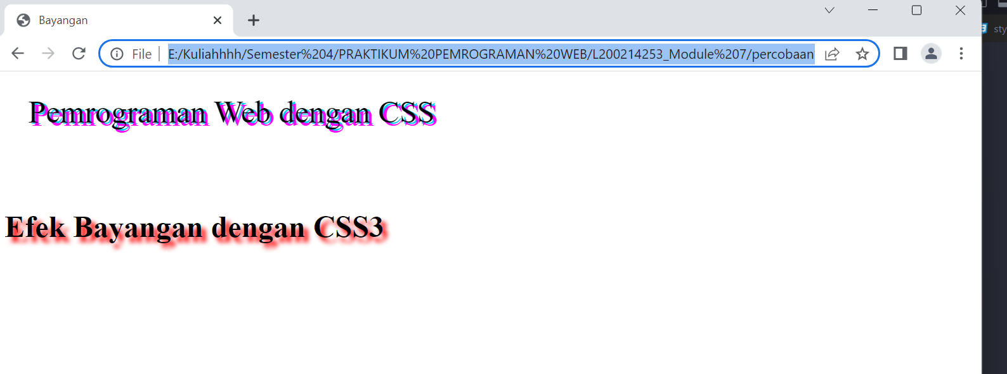

**Experiment 4**

<html>

<head>

<title>Hyperlink</title>

<style *type*="text/css">

body {font-variant:small-caps}

A*:link*{text-decoration:none; color:yellow;

background-color:lime}

A*:visited*{text-decoration:none;

color:green; background-color:lime}

A*:active*{text-decoration:none;

color:yellow; background-color:lime}

A*:hover*{text-decoration:none; color:white;

background-color:lime}

</style>

</head>

<body>

Hyperlink Menggunakan CSS</br>

<a *href*=”#”>tombol 1</a>

<a *href*=”#”>tombol 2</a>

<a *href*=”#”>tombol 3</a>

<a *href*=”#”>tombol 4</a>

</body>

</html>

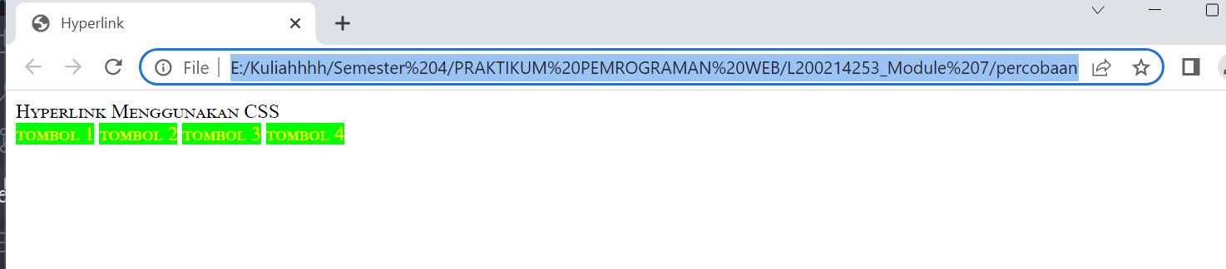

**Experiment 5**

<!DOCTYPE *html*>

<html>

<head>

  <link *rel*="stylesheet" *type*="text/css" *href*="form.css">

</head>

<body>

  <form>

    <label *for*="name">Nama:</label>

    <input *type*="text" *id*="name" *name*="name">

    <label *for*="email">Email:</label>

    <input *type*="email" *id*="email" *name*="email">

    <input *type*="submit" *value*="Submit">

  </form>

</body>

</html>

**CSS**

form {

  width: 300px;

  margin: 0 auto;

}

label {

  display: block;

  margin-bottom: 10px;

}

input[*type*="text"],

input[*type*="email"] {

  width: 100%;

  padding: 5px;

  margin-bottom: 10px;

}

input[*type*="submit"] {

  background-color: #4CAF50;

  color: white;

  padding: 10px 15px;

  border: none;

  cursor: pointer;

}

input[*type*="submit"]*:hover* {

  background-color: #45a049;

}

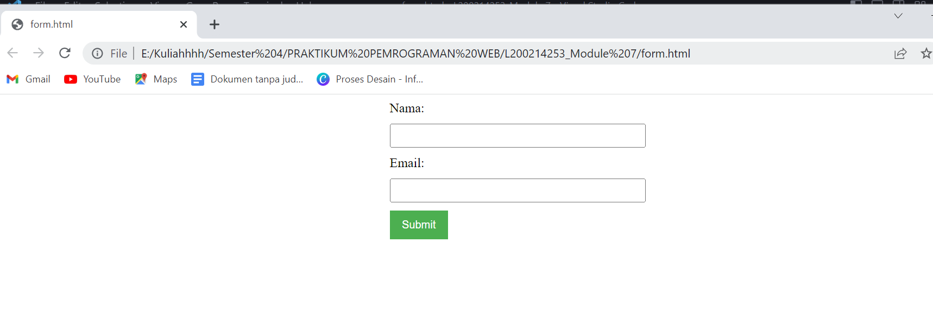

**TASK**

<!DOCTYPE *html*>

<html>

<head>

    <title>Form</title>

    <link *rel*="stylesheet" *type*="text/css" *href*="style.css">

</head>

<body>

    <h2><marquee>Free Registration</marquee></h2>

        <form *action*="proses.php" *method*="post" *name*="form">

            <table *width*="68%" *border*="0" *align*="center" *cellpadding*="0">

                <tr>

                    <td *class*="td" *width*="15%">Nama</td>

                    <td *width*="2%">:</td>

                    <td *width*="83%"><input *name*="txtNama" *type*="text" *id*="txtNama"></td>

                </tr>

                <tr>

                    <td *class*="td">Tgl Lahir</td>

                    <td>:</td>

                    <td><input *name*="txtTgl" *type*="text"

*id*="txtTgl" *size*="4" *maxlength*="2">

                        /

                        <input *name*="txtBulan" *type*="text"

*id*="txtBulan" *size*="4" *maxlength*="2">

                        /

                        <input *name*="txtTahun" *type*="text"

*id*="txtTahun" *size*="8" *maxlength*="4"></td>

                </tr>

                <tr>

                    <td *class*="td">Alamat</td>

                    <td>&nbsp;</td>

                    <td><textarea *name*="txtAlamat" *cols*="40" *rows*="2" *id*="txtAlamat"></textarea></td>

                </tr>

                <tr>

                    <td *class*="td">Kota</td>

                    <td>:</td>

                    <td><input *name*="txtKota" *type*="text" *id*="txtKota"></td>

                </tr>

                <tr>

                    <td>&nbsp;</td>

                    <td>&nbsp;</td>

                    <td><input *name*="btnKirim" *type*="submit" *id*="btnKirim" *value*="Kirim">

                        <input *name*="btnCancel" *type*="reset" *id*="btnCancel" *value*="Cancel"></td>

                </tr>

            </table>

        </form>

</body>

</html>

**CSS**

body{background:blue}

h2{font-family: comic sans ms; background-color: red; text-align:center}

table{background:grey}

*.td*{font-weight: bold}

form{border-style: double}

td{border-style: solid}

